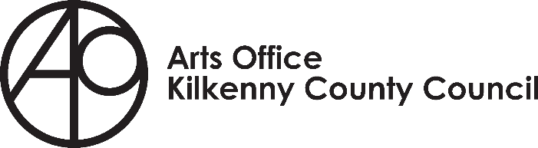
EDI Artist Bursary Application Form
Deadline for receipt of applications is 4pm on April 30th
Please read the bursary guidelines before completing the following application form. The final application form should be emailed to diane.seale@kilkennycoco.ie along with a copy of your C.V and support material.
Applicants name:
Address (please include your Eircode)

Phone number:
Email address:
Are you over the age of 18yrs?
Please confirm that you have resided in Kilkenny for a minimum of two years:
Question 1. Please provide detail regarding your eligibility as an underrepresented artist:
(max 200 words)
Question 2. Please outline your artist practice:
(max 100 words)
Question 3. Detail how this bursary will support the development of your practice, or if relevant your project. Outline the benefits of the bursary to you at this stage in your career:
(max 200 words)
Question 4. Please indicate if you wish to avail of any of the following supports i.e. mentor, coach, course, retreat, residency and how it would benefit you.
(max 100 words)
Question 5. Please complete a budget breakdown of your project itemising expenditure in detail. Provide information on all relevant sources of income. Income and expenditure will be specific to you and your project and you may not need to fill out all the suggested fields.

Please ensure that you itemise the relevant fields e.g.
- Artists fees – include hourly / daily rate
- Mentor / Coach – rate per session and please include quote from the mentor / coach
- Travel – cost per journey
- Venue hire – duration and rate – please include quote

Estimated Expenditure
Description | Cost €
Artists Fees - yours (and others where relevant)
Course Fee
Mentor or Coach Fee
Travel/ Subsistence
Equipment Hire
Materials
Publicity/Printing
Administration Costs
Insurance (if required)
Venue Hire
Other Costs (please itemise)
Total Expenditure
Estimated Income
Description | Cost € | Confirmed √
Bursary | €5,000
Private Income
Income in kind
Earned Income
Other Income: public source/ grants
Other sources (please itemise)
Total Income

Notes for completion of budget
- Provide information on all sources of income relevant to your proposed project / activity.
- Private Income means your own resources, i.e. your own earnings that you are willing to spend on this activity
- Earned Income means income from sale of art work, tickets etc.
- ‘Income in Kind’ means services or goods offered to you, i.e. if someone is willing to design posters for you for free, donate wine for the preview etc. The value of this ‘Income in Kind’ is the price of that service had they not offered it to you for free.
- Other Income means monies you have been awarded from other organisations, sponsors etc.
- Total Income means all the income listed plus the bursary €5,000.
- Give a breakdown of all expected costs, this can include:
- Artists fees with approx. breakdown of hours.
- Overhead and administration costs directly associated with this project / activity
- Travel costs associated with your project / activity and give details
- Materials you may need to buy specially to undertake this project, please note that the bursary does not fund equipment
- Cost of any public outcomes
- Advertising, PR
- Evaluation / documentation of your project
- Mentoring or coaching – please include the rate plus a quote from the mentor / coach
- Other costs relevant to your specific proposal

Checklist
- Application form
- CV
- Supporting material
- Content list
- Please send all of the above as ONE PDF document, the size of the PDF should not exceed 10MB
