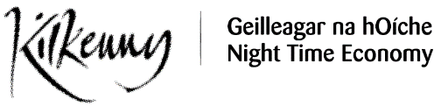
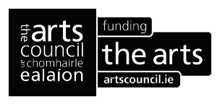

Kilkenny County Council

Arts Office

Culture Night Funding Application 2024

Completed applications together with supporting documentation must be submitted by email or post to Deirdre Southey, The Arts Office, St. Patricks Court, Patrick Street, Kilkenny

E: deirdre.southey@kilkennycoco.ie

P: 0567794547

Closing date is no later than

4pm 14th May 2024

Kilkenny County Council
Comhairle Chontae Chill Chainnigh

Culture Night 2024 Application Form

Full name and/or Organisation name:

____________________________________________________________

- Main contact:

______________________________________________________________________

3. Full contact address: _____________________________________________________________________

___________________________________________________________________________

Telephone: _________________ Email ______________________________________

Website / Blog / Social Media:__________________________________________________

5. Please give a brief description of the proposed Project/Event:

___________________________________________________________________________

___________________________________________________________________________

___________________________________________________________________________

___________________________________________________________________________

___________________________________________________________________________

___________________________________________________________________________

6. Describe your approach/how will you encourage Cultural Diversity, Diverse Participation and Arts and Disability in your event:
___________________________________________________________________________

___________________________________________________________________________

___________________________________________________________________________

___________________________________________________________________________

___________________________________________________________________________

7. Outline how your event will support Culture Night Late and the development of the night time economy in Kilkenny?
___________________________________________________________________________

___________________________________________________________________________

___________________________________________________________________________

________________________________________________________________________

9. FUNDING:

What is the estimated overall cost of the event: € _________________

How much are you requesting from Kilkenny County Council Arts Office: €_________________

Remember your income page and your expenditure pages must balance (be equal)

INCOME |  | CONFIRMED
- Own income
(eg own resources, donations etc)

Subtotal
- Other Funding Sources

Subtotal
- Income in kind
(eg services given to you)

Subtotal
- Other income (give details)

Subtotal
- Application to Kilkenny County Council
Total income

EXPENDITURE | TOTAL
Programming Costs

Subtotal
Artist Fees

Subtotal
Production Costs

Subtotal
Venue Hire & Equipment Hire

Subtotal
5. Other costs

Subtotal

Total expenditure

DISCLAIMER & DATA PROTECTION

DATA PROTECTION – Kilkenny County Council collects some personal data during the application and processing of this funding scheme, particularly names, addresses and contact details (emails and telephone numbers) These details are necessary for the consideration and adjudication on the grants scheme. The grant applications are sometimes shared between relevant County Council Departments for the purpose of supporting the application. At all stages the personal data is handled in full accordance with the Data Protection Legislation. Your express consent is required, acknowledging that you understand that you may be submitting data.

I/we have read and agree with the above terms and conditions.

Signed: ________________________________________________

Date: ________________________________________________

