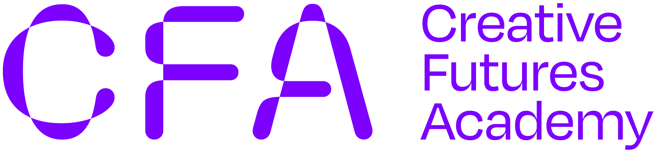

CFA & KILKENNY ARTS OFFICE BURSARY 2024
APPLICATION FORM

Our application form mirrors CFA’s Application Form as closely as possible to limit extra work on your part.

NAME:

ADDRESS:

EMAIL:

PHONE:

ARTFORM /

PROFESSION:

PLEASE IDENTIFY WHICH COURSE YOU ARE APPLYING FOR:

PLEASE ADVISE THE COURSE FEE:

HOW MANY YEARS HAVE YOU BEEN RESIDENT IN KILKENNY:
Applications are accepted from Kilkenny based artists living in Kilkenny for over 2 years.

STATEMENT OF INTEREST
A statement framing your reasons for applying to the programme, i.e. how attending the above selected course will benefit you and your practice (max. 500 words)

OTHER FUNDING / SCHOLARSHIPS
Are you in receipt of any other funding or scholarship for the course you are applying for? If yes, please explain.

CV

Please submit a recent copy of your CV with your application.
I confirm that I am over 18 and that all of the information I have provided is correct as of the date of signing. I agree to be bound by the conditions of this bursary scheme

I consent to the processing and sharing of my personal data with the Creative Futures Academy & the relevant academic institutions for the purpose of this award.

Signature: Date:

REQUEST OF TRANSCRIPTS
The institutions you are applying to will request transcripts of previous programmes and certified copies of 3rd level qualifications. They may also require additional supporting material depending on the nature of the course and your experience. It is not necessary to send these with this bursary application.

Applications will be assessed on the basis of the applicant having provided
- Evidence of how this particular course would benefit your artistic progression and the development of your practice
- Evidence of ongoing commitment to the progression of your practice
If successful you must
- Commit fully to the course including investing time in any course assignments / exercises.
- Agree to completing a post-course report regarding your experience of the course and how you will use your learning in you practice going forward. This must be returned to the Arts Office within one month of course completion

NB Successful applicants
Bursaries will not be paid out until confirmation of acceptance to the CFA course is received by the Arts Office.

DEADLINE FOR RECEIPT OF APPLICATIONS:
TUESDAY 19TH MARCH 2024, 4:00PM

Please submit your application and a copy of your CV to diane.seale@kilkennycoco.ie
Please include ‘CFA Application’ in the subject line.

For all queries contact:
Diane Seale: diane.seale@kilkennycoco.ie / 056 – 7794289

