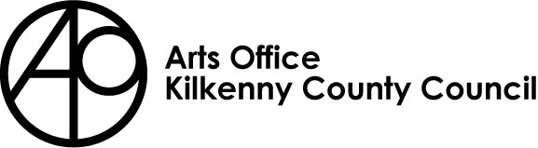
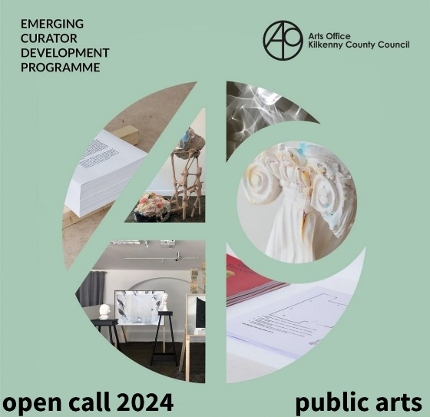

EMERGING CURATOR DEVELOPMENT PROGRAMME - PUBLIC ARTS

NB: Before applying please read this document in full, as this year, we have changed the emphasis of the residency to encourage and support those interested in Public Arts to gain real time experience of managing Public Arts projects by working alongside an experienced Public Arts Curator / Project Manager.
Kilkenny County Council Arts Office invites applications from Emerging Curators for their 2024 Emerging Curator Development Programme (ECDP). The Arts Office initiated this programme in 2019, to support emerging curators in developing and progressing their skills, experience and ultimately their careers.

For 2024 we are specifically looking for Emerging Curators / Project Managers with an interest in and commitment to developing their careers in the area of Public Arts.

The successful applicant will undertake an internship with Kilkenny County Council Public Arts Project Manager. This will enable them to gain experience in the project management, curation and administration etc of Public Arts project(s) for Kilkenny.

THE SUCCESSFUL CANDIDATE WILL:
- Undertake experiential training, enabling them to support and observe the role of the Public Arts project manager / curator and also to witness and engage with the role of the Arts Office and Public Art Management Group (PAMG) in Public Arts programming.
- Experiences how other Local Authority departments, external organisations and individuals input into Public Arts Projects, e.g. engineers, technical staff, other relevant organisations, communities etc.
- Gain experience of public arts procurement process in line with the Percent for Art National Guidelines and gain knowledge around project budgets.
- Gain experience in the development of artists briefs, contracts and other relevant material.
- Develop and expand their networks and relationships across the arts and culture sector
- benefit from working alongside a long-established Arts Department within Kilkenny County Council, benefitting from the years of experience and expertise of the Arts Officer and her staff.
- Benefit from working alongside and be supported in their learning by Vincent O’ Shea, a very experienced and Arts consultant and project manager, benefitting from his years of experience and expertise.

BIOGRAPHY: VINCENT O’SHEA - KILKENNY COUNTY COUNCIL PUBLIC ARTS PROJECT MANAGER / CURATOR
Vincent has project managed over one hundred public art projects throughout Ireland working closely with; local authorities, government departments, Transport Infrastructure Ireland, OPW, Public Private Partnerships (PPP’s), port authorities, architects, schools and communities, and through them have advocated and liaised with internal departments such as water services, engineering, housing, roads and external community representatives including Tidy Towns, memorial committees and housing associations. The public art works have included musical compositions and performance, photography publications, arts/science collaborations, residencies, film, a documentary (broadcasted on RTE), pop up museums, heritage projects, sculptural works, permanent and temporary installations. The budgets managed to date, amount to €4.4 million and commissioned artists have come from Ireland, UK, Europe and the USA. All the public art projects have been run in line with the Percent for Art National Guidelines. He is currently developing on a public art policy for Limerick City and County Council.

RESPONSIBILITIES OF THE SUCCESSFUL EMERGING CURATOR:
Support the Project Manager / curator, Vincent O’ Shea and the Arts Office, in devising and project managing a particular Public Arts project.
This will entail:
- Attending all relevant meetings as outlined by Vincent O’Shea and Mary Butler, Arts Officer.
- Liaising with other relevant Kilkenny County Council staff members in order to support the development and delivery of the project.
- Assisting in the development and production of texts for the projects including press material and social media content for the project in a timely manner.
- The development of regular blog updates, see http://kilkennyartsoffice.ie/. All updates must be approved prior to posting.
- Supporting the development of community engagement for the project. This will entail utilising existing networks and contacts of Kilkenny County Council, the Arts Office and the development of new relationships.
- The emerging curator must be cognisant of working inclusively when organising such initiatives, taking local groups, new communities, young people and diversity into consideration.
- Provide a final report and complete the Arts Office ‘pre’ and ‘post’ programme evaluation form.
- Meet all project deadlines provided by the Vincent O’Shea and Kilkenny County Council.

THE SUCCESSFUL CANDIDATE WILL RECEIVE:
- A fee including travel expenses.
- Mentoring and support from Vincent O’ Shea and Kilkenny Arts Office.

Description | Emerging Curator / Project Manager – Public Arts
Overall Period | Contract Duration – March to November / December 2024
Location | The successful applicant must have the facilities and capacity to work remotely and also be on site when necessary. The successful candidate can expect the time spent on the projects to increase at certain phases of the project. This will be discussed further with the successful candidate.
Key Relationships | Kilkenny County Council Arts Officer: Mary Butler  Public Art Project Manager: Vincent O’Shea
Fee & Details | Curators fee incl. travel and expenses will be in the realms of €6,000  The fee, including travel expenses will be finalised once the specific project(s) the successful applicant will work on has been confirmed.  The successful candidate will work on a freelance basis and will invoice Kilkenny County Council in three stages. Dates TBC.
Other | The applicant must outline:  - How a successful application would benefit their own career.  - Previous experience in arts programming, project management or curation.  - Previous arts administration experience.  - their commitment to and current understanding of the Arts / Public Arts in Ireland and beyond.  - Their understanding of the benefits of the same to *communities, *artists across art forms and *the creative sector

WHO WE ARE LOOKING FOR / PERSONAL SPECIFICATION
NB - For 2024 this opportunity is opened to emerging curators, artists, arts administrators and project managers with a specific interest in gaining experience in Public Arts to develop and enhance their existing experience as a curator / project manager.

The successful applicant should have:
- A degree in a relevant / associated field.
- Knowledge and experience of contemporary arts in Ireland and beyond.
- Demonstrable experience in the arts sector as a curator, project manager etc (albeit limited experience).
- Have proven project management skills (albeit limited experience).
- Proven very strong administration skills.
- Excellent communication skills both written and verbal.
- Proven ability to build relationships with artists, communities and existing and new audiences.
- Knowledge of the artistic and cultural vitality of Kilkenny.

HOW TO APPLY:
- Please outline: Why you are applying for this position, how it will benefit your career as an emerging curator /project manager. Please include examples of previous project management, curatorial experience (max 500 words)
- Please outline: Your understanding of and commitment to Public Arts and your understanding of the benefits of the same to *communities, *artists across art forms and *the creative sector (max 400 words)
- Up to date CV (max two pages), please include details / images of previously curated / managed projects.
- Please name two professional referees.
- Applications will be accepted by email in PDF format only. The file must not exceed 10MB.
- Please send completed application to: diane.seale@kilkennycoco.ie
- You will receive an acknowledgement of receipt for your application. If you do not receive this e-mail within 48 hours of the deadline, please contact the Arts Office on 056 779 4547.

This provision for services will run for an initial one project period with the option, at the sole discretion of the awarding authority, to extend this.
The role is freelance and the successful applicant will be responsible for all insurance and taxes which arise from any payment by Kilkenny County Council of the agreed fee including and without prejudice the generality of this provision, all income tax and VAT.

APPLICATION DEADLINE: FEBRUARY 12TH 2024, 4PM
ALL DETAILS REGARDING THE PROGRAMME AND APPLICATION PROCESS ARE AVAILABLE ON OUR KILKENNY ARTS OFFICE BLOG.

