Kilkenny County Council Arts Office 2023 Bursaries Round 2 to attend:

HAUMEA ECOVERSITY: online, self-paced 7-Week Courses

Kilkenny Arts Office is delighted to announce that we are offering Kilkenny based artists and cultural professionals a Bursary Award to study with the Haumea Ecoversity. There are two separate courses to avail of; Essential Ecoliteracy or the Earth Charter vision and values course. Both courses are for mid-career creatives and cultural Professionals, are self-paced and for all art forms.

The bursary supports professionals to attend one of the online courses.

How to apply:
Apply by sending your C.V. (max 2 pages), samples of recent work and a completed application form to:
Email: diane.seale@kilkennycoco.ie

Deadline for applications Thursday 5th October at 4pm

How the courses are delivered
Each week participants will have access to video lessons in online modules that can be engaged independently. There will be weekly group meetings via Zoom for valuable peer learning and networking with other creative workers across the world.

Who are these courses for?
We can cater to committed self-taught creatives, recent graduates to established creatives and doctoral-level creative researchers, art educators, curators, art directors and cultural policymakers. Cathy Fitzgerald runs the course with Californian-based philosopher, mentor and podcaster, Dr Nikos Patedakis.

PLEASE NOTE: these courses are NOT for experienced ecological art practitioners who will already be familiar with introductory course material. These courses are also not about making an environmental-themed artwork, NOR do they review others' ecoart work in depth. Instead, the primary focus is to offer you accessible context, knowledge,language, vision and values resources to enable you to confidently frame and communicate your creative or education work in a ecological context that is relevant to your situation and place.

For more information please visit Haumea Ecoversity at: https://HaumeaEcoversity.ie/

Course Details

ESSENTIAL ECOLITERACY COURSE:
MEETING WEEKLY TUESDAYS, course opens 24th October, meeting online weekly for 7 weeks from 24 Oct – 12 Dec 2023 | 7 pm Irish / UK time

GET THE BIG PICTURE OVERVIEW
Informed creativity has imprtant social power to inspire others to embrace a more beautiful, just and sustainable culture. However ecoliteracy – ecological understanding – of the immense cultural shift we need to advance a better world, is a big topic! In this course, you will learn why ecoliteracy and philosophy can assist creative practitioners and professionals in developing impactful: creative practices, exhibitions, events, community art programmes, art courses, or help you develop insightful cultural leadership for these urgent times. Discover insights from leading voices in philosophy and ethics, ecopsychology, environmental science, economics and activism, ecological art practice, and from the world's wisdom traditions. You will also be introduced to nourishing practices for personal and planetary wellbeing.
POSITION YOUR WORK
Become fluent with an ecological worldview, language, concepts, frameworks and practices that are vital to communicate and advance a life-sustaining culture. Such understanding will be valuable if you or your cultural institution wish to secure funding for creative aesthetic and community engagement opportunities. Some past learners have been successful in gaining funding for ecological creative endeavours.

EARTH CHARTER – VISION AND VALUES FOR A BETTER WORLD COURSE
MEETING WEEKLY Wednesdays course opens 17 January, meeting online weekly for 7 weeks from 17 Jan - 6 March 2024 | 7 pm Irish / UK time

Join Cathy Fitzgerald with philosopher Nikos Patedakis to understand why the accessible and holistic values of the peoples and UNESCO-endorsed Earth Charter are crucial to help us begin conversations of what matters most for a more just, equitable and sustainable world.
Through exploring the Earth Charter and the Childrens’ Little Earth Charter, become fluent in more expansive values and the shift globally toward Education for Sustainable Development (ESD). Values education is now seen as fundamental to guide: individuals’ creative work, teaching, curating; cultural institutions' sustainability communications, programming or education outreach; to foster inclusive community dialogue for ecosystem restoration endeavours; and to deepen sustainability and social justice understanding for those working in science, law, industry, politics, faith communities or business.
Building on the popular 'Values module' of the Ecoliteracy course, learn with Cathy Fitzgerald and Nikos Patedakis about why the holistic ecosocial values of the Earth Charter, advanced by peoples' from diverse cultures from across Earth since 2000, is an inspiring ethical moral compass to guide and communicate our actions toward a thriving, more just and peaceful world.

ABOUT THE TUTORS:

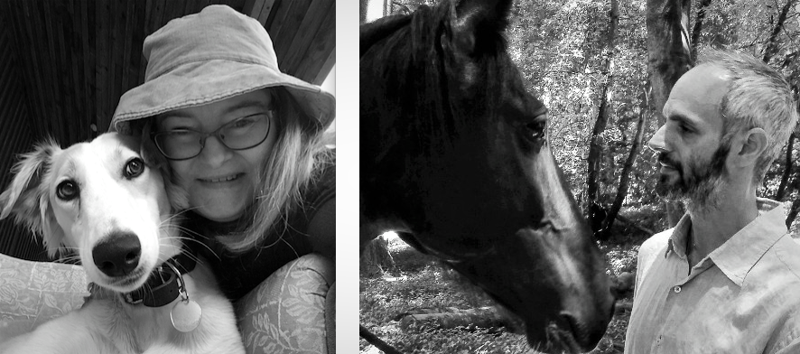

Cathy Fitzgerald
Living in the home of her Irish ancestors, New Zealand ecological artist Dr Cathy Fitzgerald is a popular educator offering accessible ecoliteracy and values training.

Pioneering ecological arts practice and research, Cathy is also an accredited ESD transformative learning Earth Charter educator and an alumnus of Earth Charter International, who host the UNESCO Chair in ESD. With her arts background, and previous careers in research science and professional development, Cathy is passionate about empowering adult creative and cultural professionals for this urgent era of sustainable cultural renewal for personal, collective, planetary and intergenerational wellbeing.

Nikos Patedakis

Nikos is an experienced philosopher and independent educator whose transdisciplinary work arises at the intersection of Nature and Culture - the sciences, the arts and the wisdom traditions. Nikos left academia to focus on helping professionals of all kinds to learn to think the way nature works, by taking advantage of what he sees as the single greatest untapped cultural resource humanity has: the philosophical wisdom traditions of the world.

Nikos sees art as having a special relationship with philosophy. Both philosophy and art seek to see the world with fresh eyes and an awakened heart. Nikos offers training to creatives and cultural professionals that transforms both their experience of life and their practice of creativity and art making.

Kilkenny County Council Arts Office

HAUMEA Ecoversity Bursary 2023

APPLICATION FORM

NAME:

ADDRESS:

EMAIL:

PHONE:

ARTFORM/

PROFESSION

Please select which course you are interested in applying for:

ESSENTIAL ECOLITERACY COURSE (24th Oct – 12th Dec 2023)

EARTH CHARTER – VISION AND VALUES FOR A BETTER WORLD COURSE (17th January – 6th March 2024)

List your most important exhibitions, performances or publications during the last 3 years. Give details and venue:

Description of why this bursary will be of benefit to you and your career:

Materials enclosed with this application i.e. Books, manuscripts, photographs, video links, scores, flyers etc:

I confirm that I am over 18 and that all of the information I have provided is correct as of the date of signing.

Signature: Date:

Deadline for receipt of applications:

4pm Thursday 5th October 2023

Return to:

Diane Seale at diane.seale@kilkennycoco.ie

