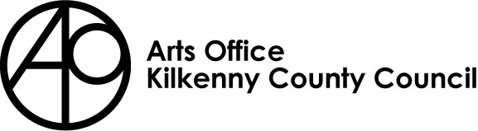
VISUAL ARTISTS MENTORING PROGRAMME APPLICATION FORM 2022
This mentoring programme offers the following benefits to artist:
- Expert guidance
- Objective, independent advice
- Relevant and practical support
- Confidential assistance on sensitive issues
- A sounding board to help in making decisions

This opportunity is for:
- Emerging visual artists who can demonstrate a commitment to their practice
- Visual artists who have already exhibited in groups or solo shows who feel they could benefit from further professional guidance and advice
Closing Date:
- Please ensure that you read the form fully and complete all sections
- Incomplete applications will not be processed
- Remember to allow sufficient time for completion and delivery of application before the closing date.
Eligibility:

- Applicants must be resident in Kilkenny for a minimum of 2 years
- Applicants must be registered with ArtLinks

Personal Details
Name
Current residential address
Email
Mobile
Website
Social media
Give details of any other previous awards received, including those from national and local organisations, e.g. Arts Council, ArtLinks, Local Authority, other professional organisations.
Title of Award | Year Received | Amount Received

Previous professional development courses

Please list details of any professional development courses you have attended in relation to your practice
Title of Course | Organised By | Year Attended

Purpose you wish to avail of the mentor for
please prioritise one area of your practice, if other areas come to the fore as part of your sessions we will endeavour to meet those needs and allocate you a session with another relevant mentor (any session with a different mentor must still not exceed 6 sessions in total)
Tick all that apply, in order of preference
Developing & progressing your practice
- Working in context with the wider community / socially engaged practice
Applying for commissions & public art
finance, budgeting and applying for funding
Creating sustainability for your current artistic practice
Marketing your practice & MAXIMISING ONLINE AWARENESS
criteria
your application will be assessed on the basis of you having identified as part of your application:
- your needs for specific mentoring
- what you hope to achieve as a result of your mentoring
- how the mentoring will support you in progressing your practice

- Give a brief description of the purpose for which you are applying for this mentoring support and
- a statement of benefit outlining why and how you think you & your practice will benefit from the mentoring how you believe this support will develop your practice
- (Max 300 words)
- please include your artists cv & a maximum of five images of recent work

If successful, the mentee agrees to
- commit fully to the programme
- liaise with their mentor to organise a maximum of six sessions between may & mid-November 2022
- invest personal time in preparing for the mentoring sessions where relevant
- agree to completing a post-mentoring evaluation form and return it to artlinks.ie@gmail.com by the agreed date in their offer letter.

I have read the conditions applying to visual artists mentoring 2022. The information I have supplied is correct to the best to my knowledge. I agree to be bound by the terms and conditions of this scheme.

Signature:
Print name:
Date:

Completed application forms must be received by
4pm Tuesday May 3rd 2022

Please email you application to artlinks.ie@gmail.com
with KILKENNY VISUAL ARTISTS MENTORING in the subject line

