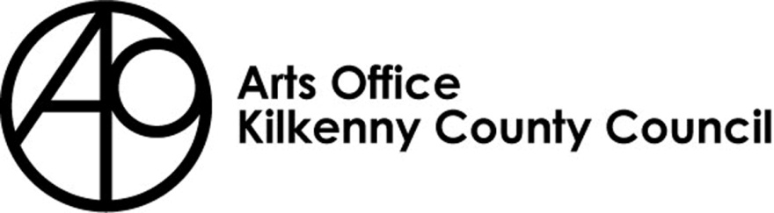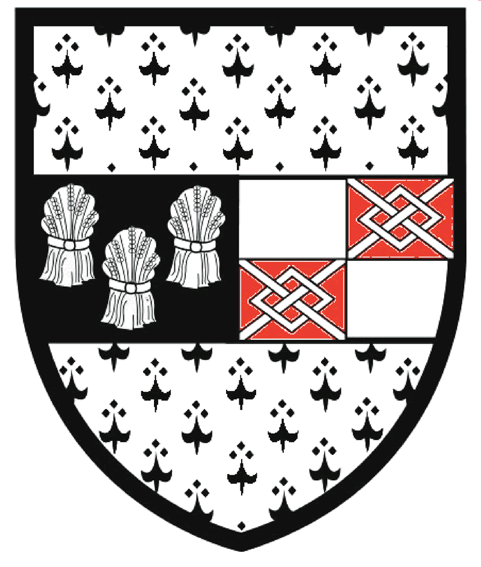

Kilkenny County Council Arts Office

CREATIVE WRITING AND VISUAL ARTS SCHOOL ARTS BURSARY - 2022

Return completed applications to:

bernadette.roberts@kilkennycoco.ie

or

Bernadette Roberts

Kilkenny County Council Arts Office
Johns Green House, Johns Green R95 YH61

Please title your e mail / envelope

CREATIVE WRITING AND VISUAL ARTS

SCHOOL BURSARY - 2022

Closing date: 14th February 2022

Bursary context
As part of our annual programme Kilkenny County Council Arts Office focusses on engaging with and encouraging young people and children to create, experience and participate in the arts. We have a longstanding history of designing and administering successful Youth Literary programmes including our online poetry journal www.rhymerag.net and the Rhyme Rag Ensemble (partnership with Ossory Youth) We have taken part in local, national and international partnerships, including #wearethepoets with Laureate na nÓg Sarah Crossan and Kilkenny Arts Festival (2019) and the ‘Borderlines’ international project with poet Joelle Taylor (2019). We have also published a collection of young poets in 2018 entitled ‘Mark my Words’

Arts programmes in particular can support young people in finding their voice, their emotional expression and they have a positive impact on mental health. The arts can support young people in processing new experiences and through periods of transition. These programmes can also teach them a diverse array of transferable skills supporting them in many aspects of their lives. The Arts Office recognises the importance of partnerships, such as schools and youth services, which play a significant role in providing access and encouragement to young people to engage in artistic and cultural activity.

THIS BURSARY HAS BEEN DEVISED WITH TRANSITION YEAR STUDENTS IN MIND. BUT IT IS NOT EXCLUSIVE TO TRANSITION YEAR AND IF THE SCHOOL BELIEVES THAT ANOTHER YEAR WOULD BENEFIT MORE FROM THE WORKSHOPS THEY CAN STILL APPLY FOR THE BURSARY

Art workshops can include
- Visual Arts
  - Painting / sculpture / printmaking / collage / ceramics / illustration / architecture
- Literature
  - Poetry / Prose / Drama / play writing / Short story writing / Journalism / Song writing / Journaling / Fiction / Non-fiction

Any of the literature workshops can be undertaken as béarla nó as gaeilge
Proposals for workshops combining literature and the visual arts are welcome

*AIMS & OBJECTIVES - Workshops must seek to
- Support the development of the young people’s creative expression, knowledge and skills in a fun and engaging manner
- Deepen the young people’s creative experiences and ensure that all activities are rich, challenging and rewarding
- Expose the young people to new experiences
- Strive to improve the confidence and self-esteem of the young people involved
- Develop the young people’s knowledge of the arts

The workshop aims and objectives must be clearly stated and in line with a minimum of two of the points outlined above.

Criteria
- Schools /organisations must be based in the Kilkenny administrative area
- Schools / organisations must provide the Arts Office with the name and contact details (direct phone number and direct e mail address) of one individual through which all correspondence will take place.
- The school / organisation is responsible for selecting the writers/artists. The Arts Office is happy to support and advise on suitable writers/artists where possible.
- The school / organisation is responsible for the Garda vetting of selected writers / artists.
- Each individual workshop must not be longer than 90 minutes or less than 60 minutes and there is a preference for the school to run more than one workshop with the selected groups / class of students.
- A minimum of three workshops per group / class must take place, in order to enable the students to build knowledge and familiarity with the art form they will be working in.
- If successful in their application schools / organisation must agree to pay selected artists in-line with industry standard fees. See below
  - Artists fees
Minimum - €200 for a half day of workshops
Minimum - €350 for a full day workshop (up to 3.30pm)
- Travel: artists / writers should be paid for their travel, please include an allocation for this in your application
- Materials: allocation for materials for visual arts workshops to a maximum of €200. Please include an allocation for this in your application and include receipts with your report
- The application form and budget sheets must be completed in full.
- Any additional information requested must also be included in your application
- Minimum award €1,050

NB
Any school that decides to run poetry workshops should be aware of www.rhymerag.net a wonderful online poetry journal for young writers. The website is not currently taking submissions but it is a wonderful resource for the students and teachers alike.

Conditions and further details
- The funding offered must only be used for the purposes specified in your application.
- The award must be spent and drawn down by Monday 16th May 2022
- If the proposed workshops are altered, postponed or cancelled – in whole or in part – the Kilkenny County Councils Arts Officer, Mary Butler, must be contacted in order to discuss the matter.
- Kilkenny County Council must be acknowledged on all publicity, press and marketing material, websites and social media outlets produced in connection with the undertaking or event. A copy of our logos will be sent to all successful applicants
- Copies of all such material produced must be sent to the Arts Office at the time of the event and as part of the Evaluation Report.
- An evaluation report template will be provided to successful applicants and must be completed in full including, 4 good photos in jpeg format, and returned to the Kilkenny County Council Arts Officer within two weeks of project completion. Failure to comply will result in withdrawal of the funding. The report can be returned by e mail to bernadette.roberts@kilkennycoco.ie or in hard copy FAO Bernadette Roberts, Arts Office, Johns Green House, Johns Green, Kilkenny.

Please note that any application that does not comply with the criteria and conditions will automatically be ineligible for consideration
For any further queries or clarification on the bursary please call the Arts Office on 056 779 4938
And please do not hesitate to contact us should you need support on sourcing a writer / visual artist

Remember!
- Please fill in all details. Failure to supply the information requested will result in the elimination of the application for consideration.
- Only typed applications or those completed clearly in block capital letters will be considered.
- The inclusion of any additional material, if relevant, must be clearly labelled with your name and contact details.
- Supporting information and Application Forms are available in large print on request.
- Please allow sufficient time for completion and delivery of application before the closing date as no applications will be accepted after the closing date.
- Successful applicants, if not already registered with Kilkenny County Council, will have to complete a Supplier Set Up form in order to receive payment of the bursary award.

Having completed your application please go through the Check List below.

Check List
Completed application form □
Budget □

Completed application form to be returned to:

bernadette.roberts@kilkennycoco.ie or

Bernadette Roberts, Arts Office, Johns Green House,

Johns Green, Kilkenny R95 YH61

Please mark your email /envelope clearly as

CREATIVE WRITING AND VISUAL ARTS SCHOOL BURSARY - 2022

Kilkenny County Council / Comhairle Chontae Chill Chainnigh

CREATIVE WRITING AND VISUAL ARTS SCHOOL BURSARY – 2022

Application Form - DEADLINE Monday 14th February 2022

Name of School /organisation:

____________________________________________________________

Full address:
________________________________________________________________________

________________________________________________________________________

Telephone: ________________ Email ______________________________________

Website / Blog / Social Media: _______________________________________________________________________

Bursary contact:

______________________________________________________________________

Direct phone/ mobile number______________________________________________

Direct email ____________________________________________________________

- What genre of the arts will your students engage in if your application is successful (please tick all relevant)

TYPE OF WORKSHOP | PLEASE TICK
VISUAL ARTS
- Painting
- Sculpture
- Printmaking /
- Ceramics /
- Illustration
- Architecture
- Other (please specify)
LITERATURE
please state if the workshops will be in English or Irish
- Poetry / Haiku
- Prose
- Short stories
- Journaling
- Playwriting
- Song writing
- Drama / Playwrighting
- Fiction
- Other, please specify
WILL YOUR WORKSHOPS BE IN PERSON OR ONLINE
Please explain how these workshops will benefit your students and fulfil the aims and objectives of the bursary

AIMS & OBJECTIVES - Workshops must seek to
- Support the development of the young people’s creative expression, knowledge and skills in a fun and engaging manner
- Deepen the young people’s creative experiences and ensure that all activities are rich, challenging and rewarding
- Expose the young people to new experiences
- Strive to improve the confidence and self-esteem of the young people involved
- Develop the young people’s knowledge of the arts

- Please tell us what age group / class years will take part in the workshops

___________________________________________________________________

- Please tell us how many students you intend to engage in the workshops
___________________________________________________________________

- What is the total cost of your proposed activity? €________________________

- How much are you applying to Kilkenny County Council for €__________________

- Will the school be co-funding the workshops? €________________________

*If yes, how much will the school invest in the activities (please note there is no obligation for the school to match fund but this information is useful to us for reporting and future planning)

- Has your school facilitated any art workshops /activity by external professional artists since 2017 YES NO

I consent to the processing, sharing and holding of the school’s data with Kilkenny County Council for the purposes of this award and other school related creative programmes. I understand that this information will not be used for any other purposes.

Please tick the box if you want to be added to our email database for upcoming activities, opportunities and events with the Kilkenny Arts Office. Yes No

Signed: ___________________ Date: ________________

PLEASE COMPLETE BUDGET TABLE BELOW
EXPENDITURE | TOTAL

Artists / writers fees

Please give details of proposed workshops, e.g. three half days / three full day etc

Subtotal
- Any other expenses
Please itemise

Subtotal
5. Other costs

(e.g. evaluation, documentation)

Subtotal

Total expenditure

INCOME relevant to this bursary |  | CONFIRMED
School / organisation’s own resources

Subtotal
Income in kind
(e.g. services given to you)

Subtotal
Other income (give details)
(e.g. other funding bodies, European, trusts etc)

Subtotal
Application to Kilkenny County Council
Total income

